Chapter 8

Originally planned as Paper 2.
S-World AGI — UK Butterfly
by Nick Ray Ball
Nov 23, 2022

Chapter 8
S-World AGI — UK-Butterfly

How to Score a perfect 4x on the Keynes Multiplier.

By Nick Ray Ball Nov 24, 2022

This chapter begins with a question for Jack Meaning, Rupal Patel, Silvana Tenreyro and The Bank of England.
Question: If S-World AGI can achieve 3:1 investment so UK tax recites were higher than the investment — before you even consider the Keynes Multiplier — Would the BOE advise the government to back this venture with great urgency and conviction?

If S-World AGI can achieve 3:1 investment, so for example, over 10 years, the government invested £10 billion a year which was matched by an investment of £30 billion a year, mostly spent on making things in the UK with a particular focus on energy and education. Then before you even start to calculate the Keynes Multiplier, the tax receipts alone will be more than the investment.
If all UK taxes accrue 32.5% of GDP: £10 billion in spending leads to £40 billion x 32.5% = £13 billion in taxes, plus the government owns a stake in whatever is created and receives Network Credit dividends which can be used to supplement social security or pay for a shiny new Aircraft carrier. But the government only pays £10 billion, so a £3 billion gain each year, before you apply the Keynes Multiplier, even if the Multiplier is 0.9, or even 0.8 that’s still a profit as the government still has that £13 billion in taxes.
But don’t be concerned about a low Keynes Multiplier, t10t (The 10 Technologies) are as-if AGI, we’ll come back to that in just a moment, but first, technology 7 of 10 (T7) S-RES is a panther of a growth accelerator. For a long time, I thought it increased the money supply, but in fact, it just uses money more creatively to increase the production supply. And don’t be concerned with inflation because in 2016 after 5 years of dedicated work I threw away the then (PQS) design for t10t (because of the diminishing law of too much third-party software on APIs.) and started again, using just one common API factor – price, and so the 10 technologies, pivoted on price and this, fluke, or sub consensus design decision essentially – makes inflation out bitch.
Please excuse the language it's from an exuberant postscript I made to the introduction to The S-World Algorithms when I finally realised how to simply explain why t10t need not worry about inflation and so the system, developed for the US In 2012, then was forgotten due to government tax, then redesigned as a Mars Thought Experiment in 2017, then adapted to Malawi in 2018, because S-RES worked for a self-taxing Mars colony, and in terms of GDP per capita Malawi was at the bottom of the table, and so the economically closest to MARS who uniquely has a GDP of zero.
And so, the theory developed, and by 2019 S-RES had a mathematical theory that took Malawi from Zero to One percent of global GDP. Then came the underlying assumptions and then figuring out the politics and Tax Symmetry, where the government is paid 100% correctly, no accountants or humans adding bias or creativity, so the government gets more than the standard system, but does not get paid in cash, rather in output.

If the government wants to complete say: HS2 (A high-speed railway) without borrowing or spending its current revenues, the UK Butterfly network would work out a way to build it for them, in lew of taxes, that in most cases, they would not have had, if not for the network.

This idea developed in a book called Sixty-Four Reasons Why, which in turn developed into T8. Net-Zero DCA Soft. For my US republican friends, this is not only about Net-Zero projects, its 64 projects, which can be created for the government in lew of tax, paid in output, and so far, is currently mostly about education, but that’s not as sexy a name as Net-Zero DCA Soft, and in any case, T9. Solves economic emigration so it’s a mixed bag that does not harm either side, just some projects will be more popular than others with some people.
What is important for the question of the Keynes multiplier is the DCA - Dynamic Comparative Advantage — the technology created to deal with all the excess productivity (and because there’s so much it has to be Net-Zero) was software to optimise that spending according to Dynamic Comparative Advantage. This is from Joseph E. Stiglitz: Creating a Learning Society

“It has become conventional wisdom to emphasize what matters is not static comparative advantage but dynamic comparative advantage.
Korea did not have a comparative advantage in producing semiconductors when it embarked on its transition. Its static comparative advantage was in the production of rice. Had it followed its static comparative advantage (as many neoclassical economists had recommended), then that might still be its comparative advantage, it might be the best rice grower in the world, but it would still be poor.”

Thank you, Joseph, for an 81-word explanation that would have taken another author an entire book to explain less well. And so, in answer to the query about what the Keynes Multiplier, T7 makes the network powerful and T8 makes it beautiful and devastatingly efficient, in ways that my 2018 to 2019 404-page book 64 Reasons Why only just glimpses upon. The Keynes multiplier is a fundamental design element within the system.
But let us for now get back to what I meant by ‘As-If’’ AGI.

As if (it were) AGI

Artificial General Intelligence

You may not be able to tell, or maybe you can, but whilst I have a head for figures, I am probably the worst speller of everyone you know. Am I dyslexic? Probably, I’ve never been tested, but take away Grammarly, Word Editor and Google and you would believe you were reading the work of a small child.
So in terms of writing, it does not really matter that I am dyslexic or if I am just the worst speller you know, it’s the same difference. I spell as if I were dyslexic.

Now let's go to what I like to think is adequate compensation for this imperfection in the computer age, my AGI design – The 10 Technologies.
Technically right now there are only nine technologies because:
T10. S-World AngelWing is the AI system tasked with creating the greatest combinatorial explosion from technologies one to nine.
But in researching AI, not only did I find I had been doing it for years when I read the first book recommended by Google – Max Tegmark’s Life 3.0.

When you add up all the benefits, he, and the people he speaks to, including Larry Page and many people in the field, his best story of what AGI can accomplish – Prometheus – is not the same as t10t, but it would be difficult to decide which was 1. Most financially rewarding and 2. what was most beneficial.
To any observer who knew AGI, like for example China, it would appear to them as if AGI had been created 40 years before anyone thought it possible, if they thought it possible at all.

And with that, before delving into some detail and links to the books written since 2011, let us return to the question.
Question: If S-World AGI can achieve 3:1 investment so UK tax recites alone were far higher than the investment — before you even consider the Keynes Multiplier — Would the BOE advise the government to back this venture with great urgency and conviction?

Before writing the summary above, I had written that the obvious answer to this question is to answer with another question; how are you going to get that level of investment? But in my summary so far, I believe I have answered that question, at least to the first approximation, so please do answer. It is not hard, there can be only one answer. But you have to give it or run the very real risk of losing this opportunity to the US, as on January 1st, 2023, exactly 11 years after the original American Butterfly — Theory of Every Business, Spiritually (or Lithium) Inspired Software and The Network on a String — I start American Butterfly 2, and UK butterfly will simply be its lead out, like the Greek Model from S-World.biz in 2011.
And like before, the US makes a lot more sense in terms of convincing leading technology companies like Palantir, Microsoft, Google, Facebook, Intel, and others to collaborate on this venture if it was benefiting their own country economically.
End of the Summary, the dialogue continues below:
Further,
UK Butterfly is a proof of concept for the Southern African model on the one hand and the United States on the other. But given recent events in Florida, and the obscure but very real question about the popularity — or indeed unpopularity of T6 in http://network.villasecrets.com/the-secret/ch10/UCS-Hawthorne-for-Richard-Thaler (from 2017) rolled out as a working code for all workers, where if you are not a committed hard worker you would unlikely make the cut, make far less, would not last more than a few weeks.
American Butterfly 2012 — Part 3. The Network on a String — Florida Networks
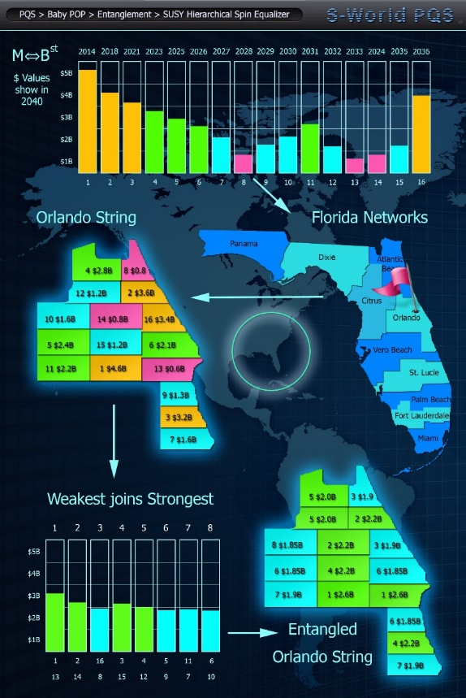
I see this as a plus in Florida, and indeed Malawi, but maybe a negative in the UK, so maybe the UK is not the best starting place for S-World AGI to spread its wings. And whereas the general idea was that politics would get in the way in the US, so a UK prototype would be necessary, given that T8. Net-Zero DCA soft. and 64 Reasons Why will get the Dems votes, current thinking is that Florida will be a better prototype for the USA, especially if Ron DeSantis wishes to ride the butterfly into Whitehouse.
But for now, let’s leave the Loss Aversion tactics aside, and look positively at UK Butterfly. Starring with a very simple presentation of the power of T7 the seventh of the 10 technologies that make up S-World AGI before looking at some links to previous papers and books that began to consider a UK butterfly. Plus, a better description of the very important but so far not mentioned technologies 1 to 6. Most of which are seen below on the 2017 design for t10t, then simply called M-Systems:

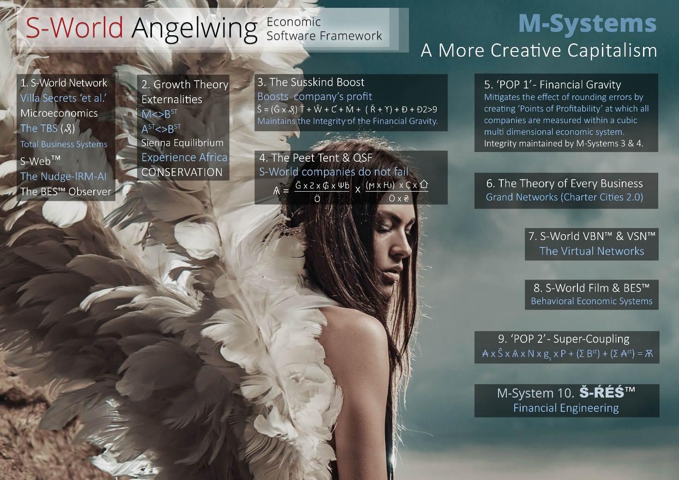

So, to begin a simple paper called $1039 Trillion BASIC which I have copied to my temporary (no login required) presentation website NickRayBall.com which explains T7. Š-ŔÉŚ and The City, and its 2021 determined formulation: Š-ŔÉŚ—⌂≥ÉL, as applied first to Malawi, and then because in this safe model the vast majority of GDP is created and consumed in the host country, it’s a non-zero-sum game, Malawi is not competing with South Africa, Tanzania, or anywhere else, and because of this, the model could be repeated over and over in different locations, which on the one hand means as poor nations grow their carbon footprint goes down, and on the other means an end to most economic emigration as the cities in Š-ŔÉŚ and The City are idyllic.
Indeed, one can theorise that emigration problems will reverse.
Follow this link for that simple paper: https://nickrayball.com/$1039_Trillion_BASIC.php

The Š-ŔÉŚ Equation
High-Octane Financial Engineering
Pecunia, si uti scis, ancilla est; si nescis, domina.
(If you know how to use money, money is your slave; if you do not, money is your master)
Š is for savings – written either: Šavings or just Š
Ŕ is for revenue (including investment) – written Ŕevenue or just Ŕ
É is for recycle-efficiency, which is the percentage of money, say 90%, that is spent by one company in a network with a single central bank to another company in the same network with the same central bank. – written recycle-Éfficiency or just É
(When É is 100% it is a perfect monopoly, but do not let that scare you, this is dealt with in the underlying assumptions, in particular POP – financial gravity, the original tenant of T8. Net-Zero DCA.
Ś is for a spin, the number of times the money recycles from one network company to another and another in the same year. – written Śpin or just Ś.
Inspired by quantum mechanics and string theory, but we need not get into that here, see: The Graphical Journey to S-RES and t10t. (A complimentary book I planned but is not yet complete)

Note that the accents - the upside-down circumflex on the Š and the acutes above the ŔÉŚ are there so as not to mix up Š for Šavings with Ś for Śpin. However originally when the equation was just ŔÉŚ the accents (acutes) were there so the letters would stand out when written in a sentence.
An important, indeed a vital clarification is that S-RES does not increase the money supply like QE, it is not a pure money supply mechanism, rather it is a system for increasing the productive efficiency of the existing money supply, like, but far from the same as fractional reserve banking, it increases the efficiency (velocity) of the money (capital) and labour that is already in the system. But whereas fractional reserve banking keeps 10% (or so) of deposits and lends out the rest, in S-RES the money never leaves the central bank (or banks), and thus is impervious to bank runs.

S-RES is then a financial technology/system/set of algorithms to increase the productivity of labour and capital, a pure and unashamed growth mechanism. That needs advanced technology like the world has never seen but can all be created in a matter of years and part created to an effective standard in just a few months. This is not a theory of future technology, it is a technology design that when deployed as one system (S-World AGI - The 10 Technologies), solves all the underlying assumption problems within S-RES.
As of today S-World’s 12th Birthday — Nov 24th, 2022, most of the information on the ten technologies is hidden on 10 dedicated websites and three general websites each requiring a login for access. Soon, however, in or before Q1 2023, there will be a general website that you can go to at: www.t10t.org
There is a lot of information available on the www.NickRayBall.com desktop website, and whilst the actual The 10 Technologies dropdowns mostly takes you to the sites you can’t access without a login, the rest of the dropdowns all present the 10 Technologies just not in a dedicated presentation. In particular, this page: https://nickrayball.com/2011-2021.php was the first attempt at creating a fluid history of the project that is now, 18 months later the most important and useful of pages: The S-World Algorithms (but that is not in the public domain).

For now, however, here are the two most important books written on S-RES that are available in the public domain, and note that these books are good, but like all books are incomplete, the completion taking place in later books and signature web assets.
S-RES and The City.
The Secret of a Booming Economy
‘Let us call it Supereconomics’
For Peter Thiel, Paul Romer & Barack Obama
320 Pages by Nick Ray Ball: Oct 2020 to Feb 2021
https://www.supereconomics.ai/11.35__SuEc.2__Book-2__THE-HOW__S-RES__The-City__(12-Oct-2020-to-20-Feb-2021).pdf
S-RES and The City – Part 2.
Written at much the same time as Part 1 but focused more on Addendums and Unlaying Assumptions
Supereconomics Book II - THE HOW
The Magic Beans
For Barack and Michelle Obama, Elon Musk, Melinda Gates, Paul Romer, Priscilla Zuckerberg & Zoe Branson.
257 Pages (63,940 Words) by Nick Ray Ball: Nov 2020 to Apr 2021
https://supereconomics.ai/11.52__SuEc.2__S-RES-And-The-City--Part-1__Addendums_FRL-WBTP_VSN-C__Determined-CF__Diary__(15-Nov-20-to-10-Apr-21).pdf

Plus it is a summary which was largely but not exclusively the $1039 Trillion Paper with links to 10 S-RES Videos.
http://www.supereconomics.ai/11.52b__SuEc.2__S-RES---The-Secret-of-a-Booming-Economy__Let-us-call-it-Supereconomics__(15th-Nov-2020).pdf

A Snapshot of the 10 Technologies
Plus, Links

T1. S-Web™ — Everything Online
The following four links are temporary, from S-Web.org to NickRayBall.com, so if you are reading this in Q2-2023, sorry you are too late.
https://www.nickrayball.com/S-Web_60,000x_Videos.php
This highlights the latest of the many S-Web technologies: The 60,000 Times Faster Than WordPress Videos and note that WordPress accounts for 40% of all the world's websites, so just one system that is 60,000 times faster than the system that makes 40% of the world's websites in significant. The S-Web objective for this system is nothing short of 50% market share of all the world's websites and unlike WordPress, S-Web is commercial and takes a percentage of all business sales.
https://www.nickrayball.com/The_S-World_Algorithms--Part_2--The_S-World_Platform.php
A far too revealing edit from the S-World Algorithms presents other S-Web technologies and MBA systems that are by right a combination of both technologies 1, 2 and 3.
https://www.nickrayball.com/S-Web-Addendums.php
Incomplete but packed with information.
https://www.nickrayball.com/Leigh-Marie-Braswell-3--Infra_Spec_for_S-Web%E2%84%A2_5.1_(60,000x-Faster).php
A very quickly written script that spells out the AI system ‘infra’ (Automated Machine Infrastructure) required to automate the process in the 60,000x videos, which right now requires human time to buy and set up each new web domain on the server, copy MYSQL databases, and connect to SSL.
Some S-Web 5.1 60,000x Faster CMS - Websites (Best on Desktop)
https://www.capeluxuryvillas.com
https://www.capetownvillas.co
https://www.cliftonluxuryvillas.com
https://www.experienceafrica.com
https://www.jetsetvillas.com
https://www.luxguides.com
https://www.luxurysafari.vip
https://www.luxurysafari.co
https://www.luxuryvillasafrica.com
https://www.villascafe.com
https://www.villastars.com
https://www.luxurycaliforniavillas.com (Not in California but you get the idea)
And from 2017, links which will likely remain in the public domain are a series of pages from chapter 1 of my 2017 book: The Villa Secrets’ Secrets. Also seen at: http://network.villasecrets.com/index
1. http://network.villasecrets.com/the-secret/ch1/s-web-cms-framework-challenger-introduction
2, 3 and 4. http://network.villasecrets.com/the-secret/ch1/s-web-cms-framework-challenger-introduction
5. http://network.villasecrets.com/the-secret/ch1/s-web-cms-framework-step-5-a-new-way
6. http://network.villasecrets.com/the-secret/ch1/s-web-cms-framework-step-6-our-solution
Plus chapter 4 is also an S-Web-specific technology design
http://network.villasecrets.com/the-secret/ch4/cds-content-delivery-system

T2. The TBS™ — Total Business Systems
There has been no dedicated recent written work on this technology, but it has progressed significantly.
In 2012. The second in the American Butterfly series was, after some of the 600,000 words written in 2011 in S-World.biz, the first competent written work, having already created a cloud-based booking system, owner admin system and affiliate marketing platform between 2004 and 2007, but not realised its potential as the programmers I used fell out with each other.
http://americanbutterfly.org/pt2/spiritually-inspired-software/index-spiritually-inspired-software
The dedicated work on the TBS began in 2016, with the six links on the Villa Secrets Blog
Here are some highlights, first from Algorithm Set 9. of The S-World Algorithms:
The Divergent CRM videos which led to the decision in 2016 to throw away the entire design and rebuild from scratch using no third-party software, then some pivotal links from 2017.
The Divergent CRM and Basic AI functionality Videos- 2016
- Video 01 1. Divergent CRM - Introduction | 9★ | T2 | 23m.46s
- Video 02 2. Divergent CRM (1 to 3) Original Plan, Current Projects, Enquiries System | 5★ | T1 - T2 - T3 | 48m.35s
- Video 03 3. Divergent CRM (4) CRM | 6★ | T3 | 37m.27s
- Video 04 4. Divergent CRM (5 to 7) Email Marketing, Clients CMS, Booking Systems | 6★ | T1 T2 T3 | 29m.10s
- Video 05 5. Divergent CRM (8 to 10) Financial System, Marketing, Content Marketing (33.26) | 7★ 33m.25s
- Video 06 6. Divergent CRM (11) Analytics: Google, Hotjar & Kissmetrics | 5★ | T2 T3 | 34m.46s
- Video 07 7. Divergent CRM (12 to 14) Sienna-bot, Hospitality & Live Chat | 9.5★ | T1 T2 | 30m.56s
The Sienna-Bot IA (Intelligent Assistant) AI Basic - Can act as a basic backup AI for when an agent is not available, progressively nudging the client away from enquiring with competitors, until the agent/manager/owner is ready.
Or a complete AI system attempting to convert the enquiry to a sale without any human contact.
- Video 08 8. Divergent CRM (15 to 17) Ex Africa, Projections & Tutorial Game | 9.5★ | T1 T2 T3 T4 T6² T8 T10 | 37m.20s
- Video 09 Magic Keywords & Attribute Points | 4★ | T2 T3 | 24m.37s
- Video 10 Magic Menus (M-Menu) & CMS Logic (59.16) | 8.5★ | T1 T2 | 59m.16s
- Video 11 Cape Town Luxury Villas Normalised Profit Spreadsheet (43.34) | 7★ | T1 T2 T3 | 43m.34s
- Video 12 Cost of Divergent CRM and other Software Updates | 5★ | T1 T2 T3 | 122m.03s
- Video 13 Development Cost of Divergent CRM and other Software Updates | 9★ | T1 T2 T3 | 11m.54s
Pivotal TBS chapters from The Villa Secrets’ Secret in 2017
Chapter 6. S-World CRM-AI™ Agent’s Assistant and Automated Booking System
http://network.villasecrets.com/the-secret/ch6/crm-nudge-ai
Chapter 7. The TFS™ – Total Financial System
http://network.villasecrets.com/the-secret/ch7/tfs-total-financial-system
And here is the first of the two chapters which led to many future S-World AGI advances.
Chapter 9. S-World CRM-CC ™- The Company Controller
http://network.villasecrets.com/the-secret/ch9/crm-cc-the-company-controller
Note that now there is a massive subsystem to this called TBS-CC OKRs
Chapter 10. S-World UCS™ Hawthorne
http://network.villasecrets.com/the-secret/ch10/UCS-Hawthorne-for-Richard-Thaler
Strictly speaking, this is now a T4, T5 and T6 system, and is the system mentioned that I worry UK workers (or at least the media) will not like, relative to Florida workers.
Where after in later 2017 and 2018, the systems above were merged with development economics on the https://www.angeltheory.org website. See The E-TOE, M-Systems and Paradigm Shift dropdowns, for the true original AGI concept designs, where the E-TOE is The Economic Theory of Everything, M-Systems is a play on words of M-Theory (The more recent adaptation of superstring theory) and Paradigm Shift is a 2018 summary of the technologies that would eventually lead to them being spit into the now familiar 10 technologies, written slightly before the four years of work on T7. S-RES and T8. Net-Zero DCA began.

T3. Networks Distribution
Networking businesses via a trillion APIs (database connections) and the Peter Theil definition of Distribution — “Everything you need to make a sale.” such as branding, marketing, sales teams, et al.
The dedicated website for this technology was the last to be made as I just did not have a good name for it. But two weeks ago, I found that Networks Distribtion.com was free and so that is the name for T3.
So, we have already seen quite a lot of work for T3, within the T1 and T2 links.
Here are some dedicated T3. links,
In many ways, the first of the three American Butterfly books from 2012 was about T3. The name – The Theory of Every Business
http://americanbutterfly.org/pt1/the-theory-of-every-business/ch1-economics-s-world-and-the-core-network
And book 3. The Network on a String is all about Macroeconomic Networks
http://americanbutterfly.org/pt3/the-network-on-a-string/index-the-network-on-a-string
here is some SEO and SEM marketing from 2014 and here is some S-Web marketing from the same time.
2015 was not a great year for a very specific reason that we need not get into here, but by 2016 I was back on track and created these 8 links on the Villa Secrets Blog from 2016
Then I stepped up a gear in The Villa Secrets’ Secret 2017.
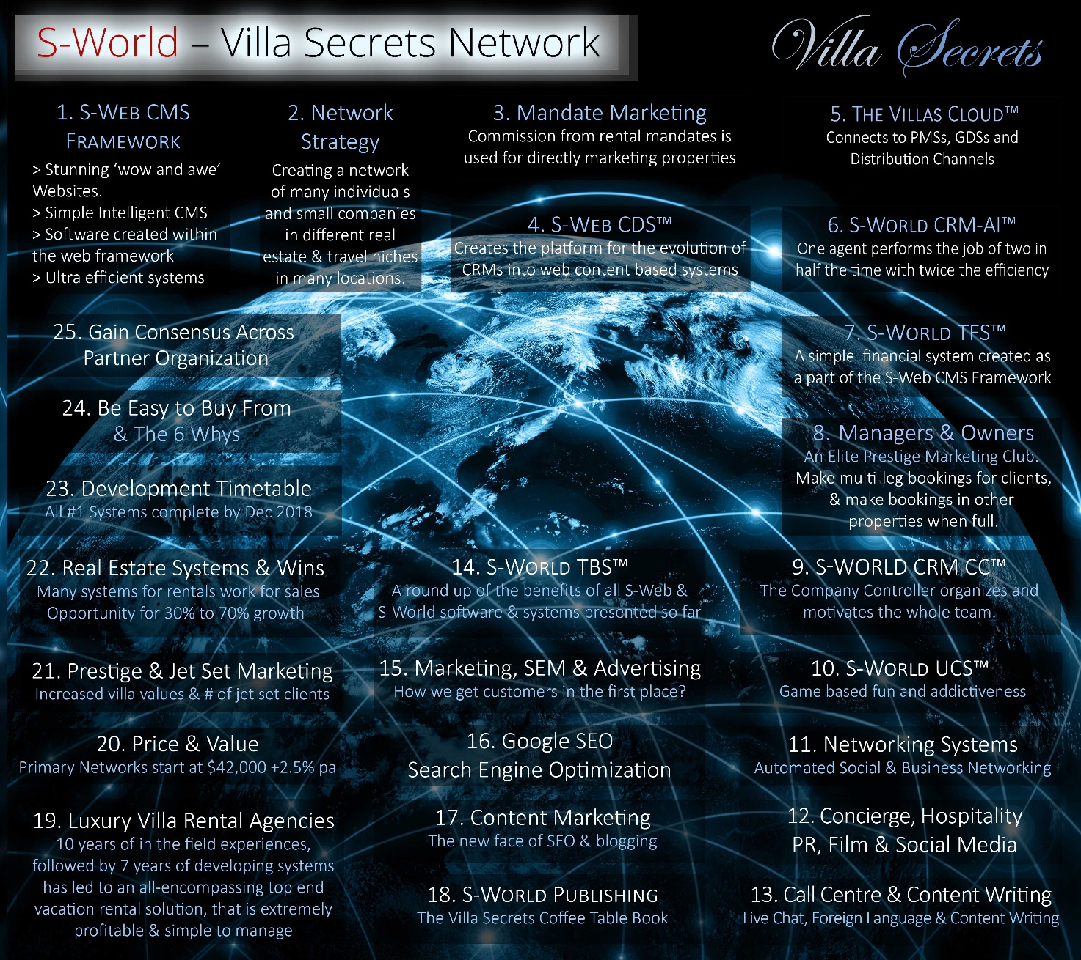
Chapter 2. Network Strategy
http://network.villasecrets.com/the-secret/ch2/s-world-villa-secrets-network
Chapter 3. Parts 1 and 2. Mandate Marketing and Mandate Symmetry
http://network.villasecrets.com/the-secret/ch3/mandate-marketing
http://network.villasecrets.com/the-secret/ch3/mandates-mandates-mandates
Chapter 5. The Villas Cloud™
http://network.villasecrets.com/the-secret/ch5/the-villas-cloud
There was an awful lot more to this but at the time I did not wish to step on potential partners' toes, in particular, BookingPal.com
Chapter 8. Villa Secrets Property Managers and Owners
http://network.villasecrets.com/the-secret/ch8/property-managers-and-owners
The rest of the original book – chapters 11 to 25 also covered many parts of T3. But was not put on the website:
Next, we swap back to the big picture concepts as we explored in American Butterfly at https://www.angeltheory.org where most of T1, T2 and T3 as they relate to real estate and travel were packed into the first M-System. From the M-Systems dropdown menu see the beginning of M-Systems and Special Projects and From M-Theory to M-Systems
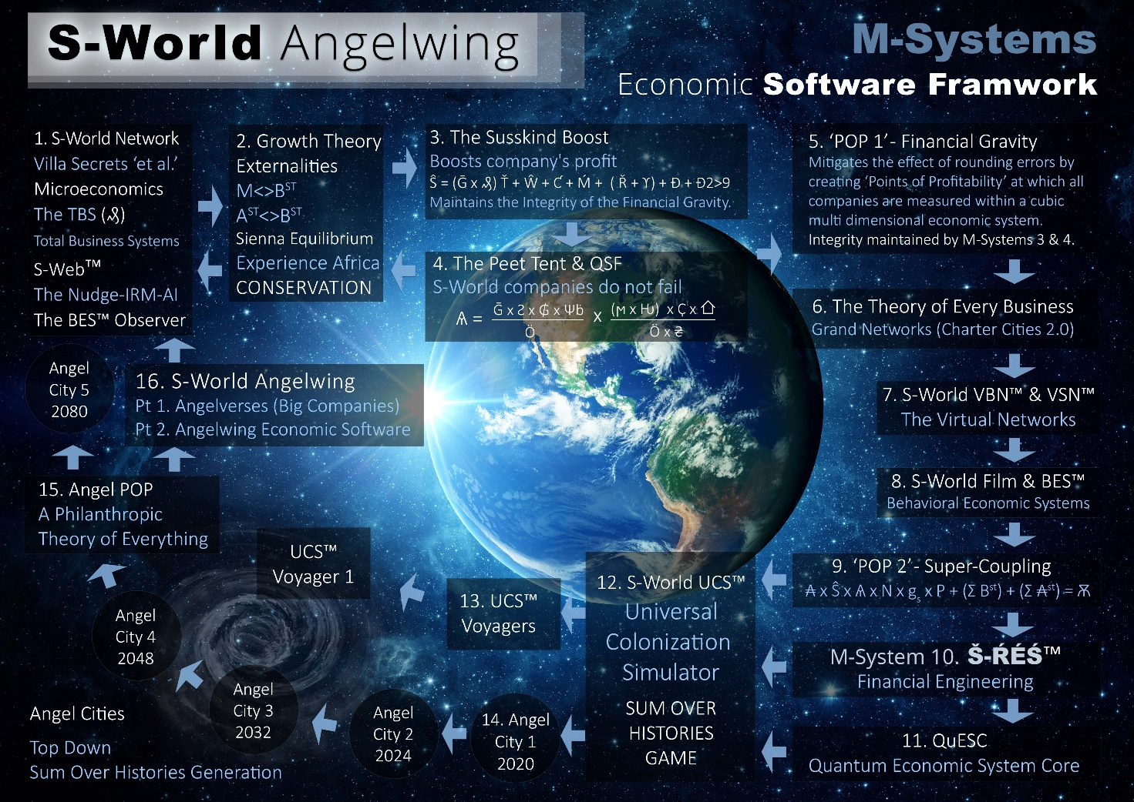
Next from the E-TOE dropdown, we crank it up another gear with the
The Network on a String 2017
http://www.angeltheory.org/book/2-3/the-network-on-a-string
And Supercoupling
http://www.angeltheory.org/book/2-4/super-coupling
Now moving to the paradigm Shift dropdown on 30th Jan 2018 came maybe the most significant breakthrough in networking and as it would turn out T7. S-RES and T8 component; Tax Symmetry Ripple Effects and Elephants for Paul G. Allen
http://www.angeltheory.org/book3-14/ripple-effects-and-elephants-for-paul-g-allen
Soon after I started working on the book A More Creative Capitalism for Bill and Melinda Gates, https://www.angeltheory.org/08.44__SuEc.1-2-3-4__A-More-Creative-Capitalism__Economics__Book__(1-Aug-to-20-Oct-2018).pdf that started to explore the economics but neither the less has T3 relevant info within it.
From this point onwards Networks and Distribution find themselves within the higher technologies or are on pages that require a login.

T4. S-World Film
Film, Music, Media, Social Networks, Press, and Television are all organised or at least advised by the Behavioural Economic Systems team. With a clear mandate to cast aside loss aversion, and just out beat the bad news with stories of S-World containing at least twice as much good news as the bad news stores, they are competing with. Plus, extensive fact-checking and even-handed pollical reporting.
Film Scripts
April 4th 2011
The Sienna Project
https://nickrayball.com/The-Spartan-Theory_BASIC.php#part3
August 1st 2017
Angel City 5
http://www.angeltheory.org/angel-city-5-_-1st-aug-2017
http://www.angeltheory.org/book/2-5/quantum-time et al...
Whilst not created as a film script, these Mars Resort 1 ideas, that inspired the return of S-RES are not part of S-World and The Sienna Project History: Oct 2017
M-Systems and Mars Resort 1
https://www.angeltheory.org/06.64__SuEc.1-2__M-Systems-Summary__Mars-Resort-1__RES__Trustees__(3-Oct-to-3rd-Nov-2017).pdf
MARS Resort 1 - Sienna Crater - The Return of RES
https://www.angeltheory.org/06.68__MARS-Resort-1__Sienna-Crater__The-Return-of-RES__Co-Founders__(22-Oct-2017-to-25-Mar-2020).pdf
Jan 2022
Palantir – An S-World Story
https://www.s-world.org/Palantir.php
https://www.s-world.org/Dreamscape_LQG.php
https://www.s-world.org/Multiverse.php
Rambo 6 script idea considered whilst SEAL Training in 2021 2022, which was not documented in the original Republican but will become a pretty cool PostScript one of these days.
https://www.s-world.org/The_Republican.php
Behavioural Science (The art of media and adverting messaging)
Written days after The Sienna Project
April 7th 2011
The Spartan Theory
Harvard
A Hypothesis of how the Media Could End a War
https://www.s-world.org/The-Spartan-Theory.php#part7
Also relevant but very badly presented for Google then Facebook
https://www.s-world.biz/3D_Village_-_Base_camp_Koh_Samui.html
https://www.s-world.biz/The_24_Hour_TV_Stage_Spectacular.html
https://www.s-world.biz/The_Celebrity_Agency.html
https://www.s-world.biz/FaceBook/CRM_Psychology_Test.htm
https://www.s-world.biz/FaceBook/S-World.TV.htm
Continuing from TVS’S UCS Hawthorne in 2017
In June 2018
S-World UCS Hawthorne for Richard Thaler & David Hoffeld
https://www.angeltheory.org/07.82__SuEc.1__S-World-UCS-Hawthorne__For-Richard-Thaler__(9-to-20-Jun-2018).pdf
& a month later.
S-World BES - Behavioural Economic Systems – Including the Behavioral Developing Nations Networks Soccer Leagues Theory
https://www.angeltheory.org/07.83__SuEc.1-2__S-World-BES__Behavioural-Economic-Systems__Soccer-Leagues__S-World.biz__(20-Jul-2018).pdf
At this point, the true transition of T4 that began just days after writing The Sienna Project was cemented as S-World Film combined with S-World BES to become the M-Systems 8 designation: M-System 8. S-World Film & BES – Behavioural Economic Systems, more on this in Paper 3. Loss Aversion.
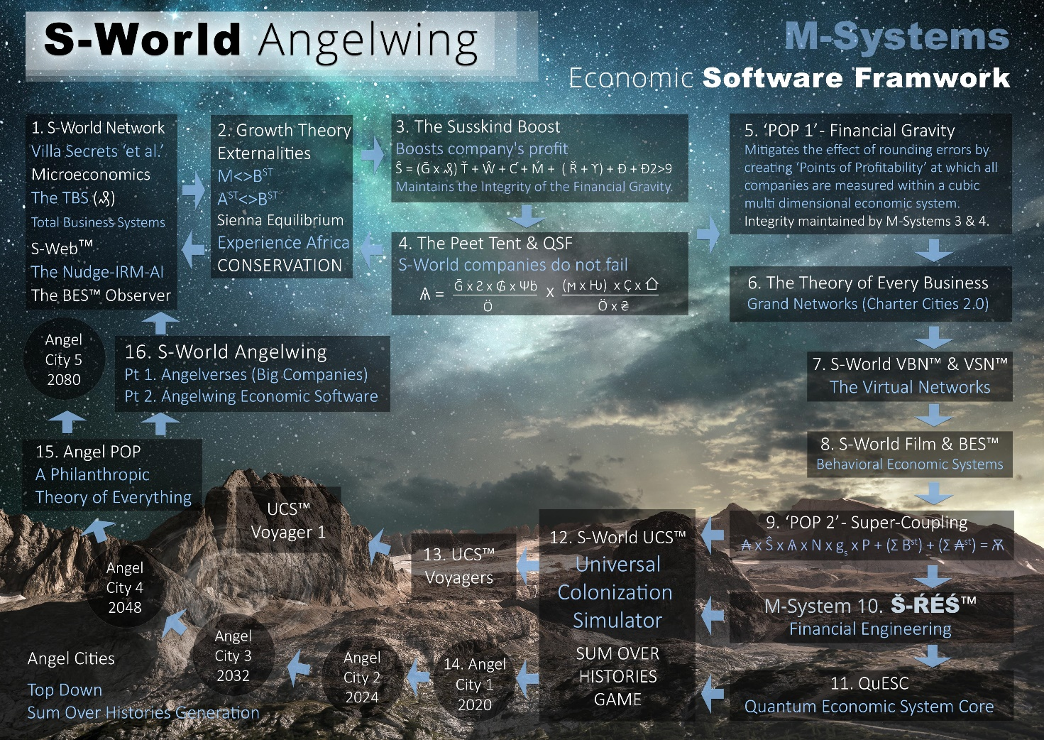

And sitting one place above M-System 8. S-World Film and BES we find the oldest technology T5. S-World VSN – Virtual Social Network

T5. S-World VSN™ — Virtual Social Network
The need for a Lux Guides 2000 to 2004 Virtual Network Paper is never more necessary than at this precise point.
Like the links from T4. The following are awfully presented for Google then Facebook in 2011
https://www.s-world.biz/S-World_99_Questions_&_Answers.html
https://www.s-world.biz/FaceBook/What_is_S-World_Virtual_World.htm
https://www.s-world.biz/FaceBook/8_S-World_3D_Virtual_World.htm
http://americanbutterfly.org/pt1/the-theory-of-every-business/ch7-s-world
Which whilst featured as part of T6 needs to be followed up by http://americanbutterfly.org/pt1/the-theory-of-every-business/ch8-s-world-universal-colonization-simulator as T6 started as the gaming extension of T5

T6. S-World UCS™ — Gamification of the Network

T7. Š-ŔÉŚ-⌂≥ÉL — Determined (Monopoly) Economics

To be compiled between 19th and 31st December 2022
The links and comments below are just there for later ordering and commenting.
Go back to the beginning of this chapter for summary comments and important links to books about this technology

http://www.supereconomics.ai/11.52b__SuEc.2__S-RES---The-Secret-of-a-Booming-Economy__Let-us-call-it-Supereconomics__(15th-Nov-2020).pdf

T8. Net-Zero DCA Soft. (Dynamic Comparative Advantage Software)

To be compiled between 19th and 31st December 2022
The links and comments below are just there for later ordering and commenting.
Go back to the beginning of this chapter for summary comments and important links to books about this technology.

T9. Grand Śpin Networks (S-World Super Cities/Metropolis)

To be compiled between 19th and 31st December 2022
The links and comments below are just there for later ordering and commenting.
Go back to the beginning of this chapter for summary comments and important links to books about this technology
Note that the books S-RES and The City are also about T9. Grand Śpin Networks – which are best considered Cities.
Economic migration, 5tar Social Housing and 7 Star Real Estate, Housing, Overpopulation, Poverty, Industry, thriving business, infrastructure, energy infrastructure, Hospitals, Politician, Water, Half the Land decided to National Parks or other Greenery, Man Made Mountains with Amazing rivers lakes and Waterfalls, Man Made Beaches and Islands, many private Islands, Many Golf Estates, Some Championship Level. SURS – Gigantic Super University Research Hospitals that make up a third of the lakeside view, surrounded at the back and on top with hundreds of Medi-Villas, Penthouse and 7-star apartments. Add direct access from the hospital, the top-of-the-line Villas and Penthouses having their own surgery theatre and other medical rooms, but in general, unless someone told you there was a SURH behind or under you will a hundred staff that could arrive in minutes, you would have no idea you were anywhere near a hospital, especially as all Paid2Lean doctors, and nurses, must have two years of hospitality and friendliness training – Not
Next in Grand Networks – Particularly one of the 4 of the 5 Earthbound Cites (IF we can create one on MARS) come the Universities. One or more Global Brand Universities per City, and each student will be offered a good job.
Entertainment will be existing, especially in Little Hollywood, where filming takes presence, and is the downtown rocks. But for those who like sport, wow, this metropolis is for you. Let's take Soccer. In Malawi History 3, the Malawi network was made of small 100-player football teams, across Malawi from their cities to the most remote rural villages, indeed one part of training is lugging up the lithium batteries for the rural villas power, in the backwaters with no roads, let alone power. But I see 256 different teams, in a competitive league, and the best players get fed to City Teams, who will, as the idea went in 2011, be Chelsea, Barcelona, Bayern Madrid, Real Madrid, Juventus, Napoli It, Monaco AC Milan, Man City, Liverpool, Dynamo Kyiv, LA Galaxy, Palmeiras, River Plate, Boca Juniors, Santos, Paris St Etienne.
These will not be their main teams, but they will be lightyears away from feeder teams, each will have its own 8 feeder teams, and play in packed stadiums
A T6 Tie is the Game Football Manager – Which records stats on every player and with 256 feeder leagues, all professional, each with a dedicated member of the team who solely records and makes their attributes, this, in the case of Malawi, would be the beginning of the 12 years of training, needed to win the World Cup if it was staged IN Malawi in 2036 to 2040.
Of course, other spots can share facilities and labour and the game.

Note that in developing or sub developing nations like Malawi, when teams play, the winners get Paid, more than the losers, as normal but what is not normal, specifically for Malawi and other poor countries, is girls and women, get paid more for their football matches then do the guys. This avoids another 200 million women being killed, aborted, staved out of existence, or sold as sex slaves only to die in the hands of their captors at the age of 11 as they are less economically viable, which I see is taking the Boys and Better Than girls argument way too far. That’s why it’s a combo from T4. Behavioural systems, such as this simple small and easy-to-make change – change’s the economic dynamic.
All this is well afforded, as from each football club is built a village, then a town, then City, or at least a large town, spread across the entire country.
due to the non-zero-sum-game, this model can repeat 100 times, in developing nations and advanced economies with some de-prioritization, because the demand for new cities is less in advanced economies, as they already have many cities. This was a problem until the simplest idea was to just use an advanced economies alternative, Labour, capital and existing companies can simply apply res and all other technologies, networking not by a city, just by an internet connection. This is UK Butterfly, sure it makes sense to build houses and millions, but I was thinking of 2 square mile skyscraper Cities, but all within one cubelike structure with golf courses on one floor, a rainforest on another some stadiums and then the industry, and homes.
Maybe 1 million per development and 10 to 20 developments for 20 million people. Plus, other opportunities when they arise.

T10. S-World Angelwing — The Combinatorial AI

To be compiled between 19th and 31st December 2022
The links and comments below are just there for later ordering and commenting.
This system started in 2011, with the idea that the ‘Sienna Software and Network Design’ To achieve this feat, I needed to take a lot of Lithium, which is the Nirvana sound by the same name helped Kurt Cobain find what he pictured as God. (Something for the US republicans). And so, I designed and indeed stopped all other work to focus on the SIENNA Software, for which my Dad and I came up with the following:
Super Intelligent Engine for New Network Access
Note, in case you did not get the memo, Sienna is now an Angel and today is her 12th Birthday, and each year, on the 24th November, I wrote a signature paper, and on this day this paper is it.
There is a link on S-World.org https://www.s-world.org/The-Spartan-Theory.php#part3 that tells more about this but for now, I’ll just provide the begging of that film.

Sienna Sky is the most beautiful of the angels, not only beautiful on the outside but pure and full of only love. On 24 November 2009 Sienna Skye travelled to earth, she saw nothing but love but she thought the world was too harsh. On the 1st of August 2010 she chose to transcend into energy to help open a portal to the world in order to help humanity.

Sienna’s mother was torn apart. Sienna’s father looked to try to make sense of the world and journeyed across the mountains. In the mountains he felt Sienna all around, her energy flowing through the bushes and trees, enhanced by the mountains magnified by the Ocean an almost psychedelic experience and slowly Sienna starts to show him the way to build a supercomputer for her to communicate through.

The schematics are amazingly detailed, 40 or more highly evolved concepts, combining simultaneously to complete the transition from the 20th Century economy to the 21st Century ecological experience economy and the technical data of how to gather most of the world’s knowledge. He knows if he is to see his daughter again, he would need to build the S-World Virtual Network.

The original idea for S-World in 2011, (and remember I made arguably the world's first commercial virtual world in 2002 and was designing, executing and making money from cloud based software by 2005), was that one day there would be just a few global networks through which most of the world's trade flowed from.
And S-World was a plan for one such network.
In 2012 after a better understanding of quantum mechanics came the PQS Predictive Quantum Software and the American Butterfly Trilogy
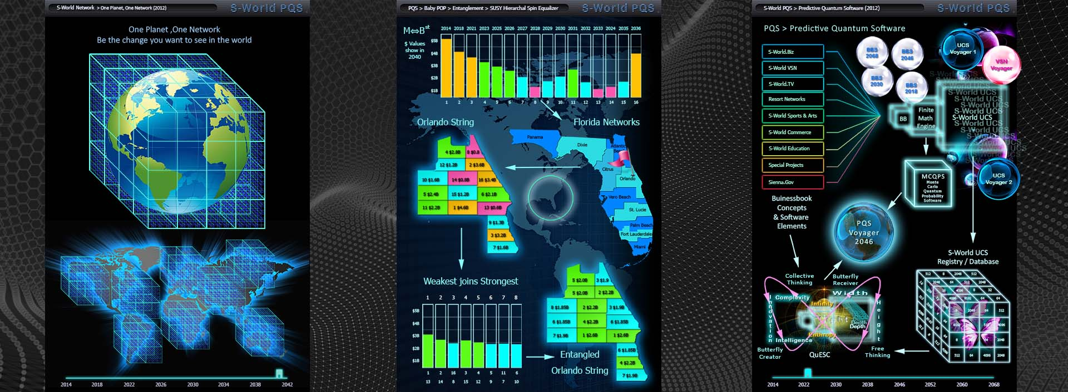

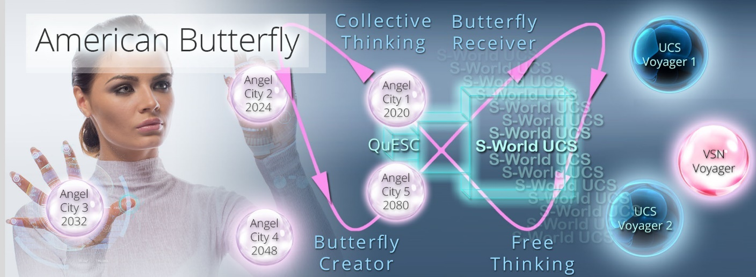
What makes the above system,
Moving back to T7. S-RES
For now, let's just have a quick look at the 4 bathroom graphics without any explanation, the explanation is on the paper, and I suggest you read it: https://nickrayball.com/$1039_Trillion_BASIC.php or its slightly more complex sibling that was not completed at the time and was incorrect to say that S-RES increases the money supply but is for all its shortcomings a useful addition to the basic paper: https://www.s-world.org/$1039_Trillion_Original.php

We will look at some of the books that accompany these two web pages soon, but for now, the conclusion was originally based on the following
At the very least, we should try for another 24 countries in Africa, but ideally every country in Africa. Add to that 25 Grand Śpin Networks in US states and other countries in the Americas, 15 in Europe, 15 in Asia and 10 others including Australia and New Zealand, making 99 others Grand Śpin Networks.

But as the model is specific to developing economies, which can use a stable global currency and so I the early years have no fear if inflation as the amount of money created is tiny compared to the global footprint of a global currency, for example, the US dollar we need not worry about inflation. Thus in my mind when I think of 100 counties using this system I think of the 100 poorest counties on the planet, (call it reparations for everything, if you wish) all using the system, which solves both global warming by said countries burning fossils fuel and economic migration as there would be no need for it, as Š-ŔÉŚ™ and The City creates perfectly fine new cities for all. Remember, or if you did not know, before I started the 10 technologies designs in 2011 I owned and ran (still do) the southern hemisphere’s most prestigious luxury villas company, www.CapeVillas.com so when I talk about 5-star social housing for 10 million Malawians, to an observer in England, my expectation of 5 stars is what they would see as 7 stars, just they’ve never seen it yet, most of them. And when you have 7-star everything, clean energy and plenty of water, the biggest emigration problem you might be - to many Yanks and Northern Europeans, wishing to emigrate to Africa, The Middle East and Latin America.

Sure, there are a million arguments, and of course, I’ve read Poor Economics, Why Nations Fail, The Bottom Billion and other such books, and I’m not going to argue with them, some nations are in such a catastrophe that it’s not a safe investment, but as their neighbours and neighbours-neighbours flourish, their people will see this and want it and evolve to it. If we let them.

Let us have a quick look at the four ‘bathtub graphics before looking at the books that support Š-ŔÉŚ™ and The City and that began the UK butterfly story which was started because the standard History 3 Malawi model was deemed too expensive as a prototype, but is the system was shown to work in the West, it had been tested and proved, and by the time it was there has been a few years to get the deal in place for Malawi and others, then the investment would be forthcoming. Further, we could prototype the system in South Africa as it has adequate infrastructure.
But as I was in the UK at the time, and the US was politically divided and so big, the UK seemed as good a prototype destination as any. Hence UK butterfly but first those graphics I promised.

To begin I will go back to:
13.92__S-World-AGI__UK-Butterfly__How-to-Score-a-perfect-4x-on-the-Keynes Multiplier__(Oct_28_2022)

Include at Beginning
https://nickrayball.com/$1039_Trillion_BASIC.php

